**Joseph in Egypt**

**Help the brothers find their way to Egypt:**



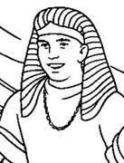

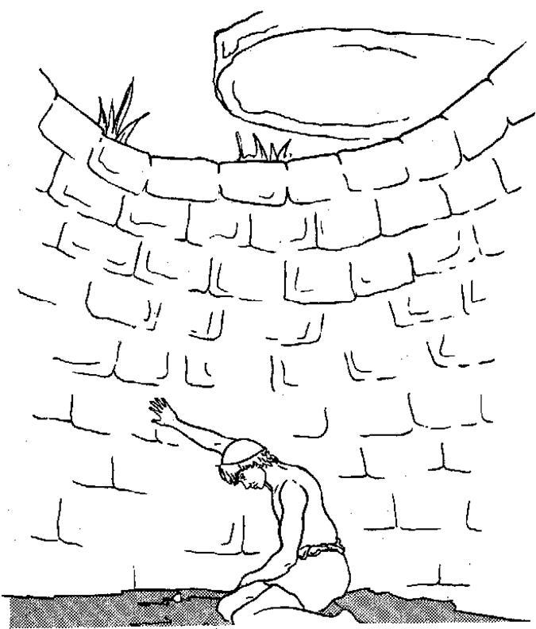

**Joseph is Sold as a Slave in Egypt**

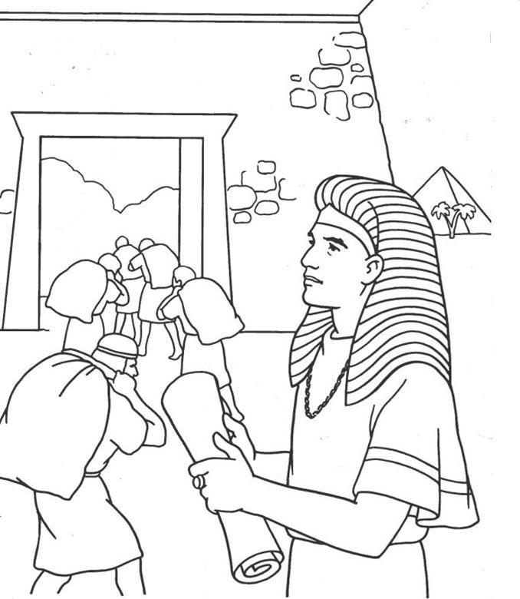

**Joseph Becomes Pharaoh’s Minister**

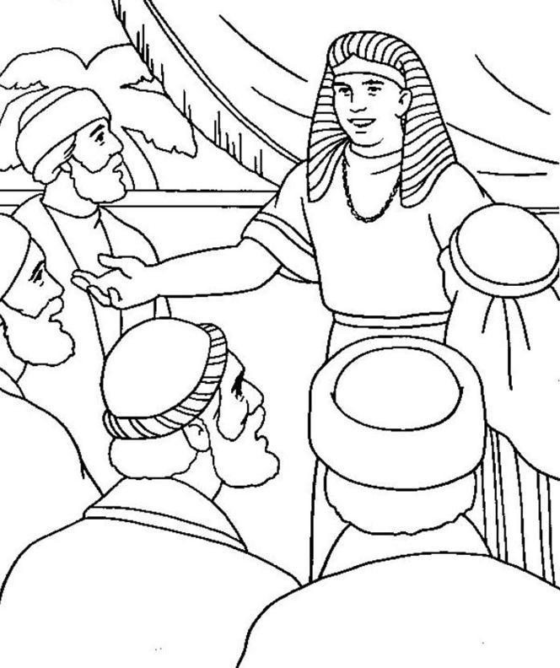

**Joseph Reveals Himself to His Brothers**