Joseph #1 (Middle School)
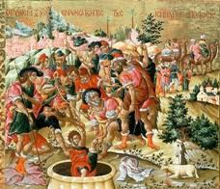
Objectives:
- Students should be able to name Joseph and his brothers as the 12 children of Israel.
- Students should be able to tell the story of Joseph and the many-colored coat and of Joseph sold into slavery.
Lesson Plan:
- Begin with prayer
- Read Genesis 37.
- Add Joseph and his brothers (Reuben, Simeon, Levi, Naphtali, Issachar, Asher, Dan, Zebulon, Gad, Judah, and Benjamin) to the family tree; Joseph and Benjamin will be under Jacob and Rachel, the rest under Jacob and Leah.
- Talk about a dysfunctional family! Questions to contemplate:
  - What is your favorite memory of family life?
  - Least favorite?
  - How would Joseph have answered that question?
  - Who was at fault for the disastrous outcome in the pit?
  - What part did Jacob play? Joseph? The brothers?
  - How could each of them have changed his behavior to avoid the disastrous end in the pit?
  - What about your least favorite memory? Who was involved? How could it have turned out differently and why didn’t it?
- Weave a “Many-Colored Cloth”: Take 1 inch strips of construction paper (provided) and weave the strips together to make a colored “remnant”. You can embellish the remanant with additional glitter/glitter glue/ sequins, etc if desired.
- Close with prayer. Pray for your family and the relationships between yourself and your parents and siblings.

