The Tower of Babel (Middle School) 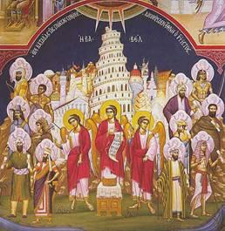
Objectives:
- Children should be able to identify the Tower of Babel and tell its story.
- Children should identify the source of the many languages we have today.

Lesson Plan:
- Scripture Reference: Genesis 11:1-8.

- Discussion: Do you speak another language? Many of the children have no idea what it is like to not understand what someone is saying; indeed, travel to a foreign country is one of the only ways to bring this lesson home. But, give it a try. Begin the lesson in another language, or give the instruction for the crafts in another language. Watch the blank stares and discuss their reactions. Acting is not your thing? Don’t know a language? Discuss war! What similarities do all people share? Differences? What are some reasons for war? How do diplomats try to resolve these differences? How do cultural and language differences make resolving problems hard? What can we do to better understand people of a different culture and language?

- Craft project: Build a Tower of Babel.

  - Take the large red cup and turn it upside down
  - Take the small red cup and turn it upside down, then place it on top of the large red cup. Glue or tape it to the large cup to create a tower
  - Glue the pom-pom ball on top of the tower to represent a flag
  - If desired, draw windows and bricks on the tower using a black sharpie.
- Add a special prayer this week for any conflict going on in the world today.

