The Tower of Babel (6-9 yo) 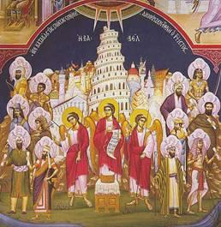
Objectives:
- Children should be able to identify the Tower of Babel and tell its story.
- Children should identify the source of the many languages we have today.

Lesson Plan:
- Tell the story of the Tower of Babel from the Children’s Bible Reader, page 28

- Have the children tell you the story back while building a tower of blocks and finally knocking it down.

- True/False questions:
True False
The Tower of Babel was the tallest ever. God built the Tower of Babel
Men built the tower to reach heaven. God told people to build it.
God destroyed the tower. People always had many languages.
God confused the languages. The tower was made of wood.

- Do you speak another language? Many of the children have no idea what it is like to not understand what someone is saying; indeed, travel to a foreign country is one of the only ways to bring this lesson home. If you do speak another language, try asking your children some simple questions in the foreign language to help them understand how the people felt after God confused their languages

- Craft project: Build a Tower of Babel.

  - Take the large red cup and turn it upside down
  - Take the small red cup and turn it upside down, then place it on top of the large red cup. Glue or tape it to the large cup to create a tower
  - Glue the pom-pom ball on top of the tower to represent a flag
  - If the children want to, or are able to, they can draw windows and bricks on the tower using a black sharpie.
- Color the color page of the tower.

