ISAAC Middle School

Isaac
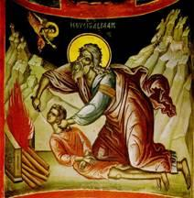
Objectives:
- Students should be able to tell the story of Isaac – his birth, the sacrifice on the mountain, and his marriage.
- Students should identify Isaac as the son of Abraham and Rebekah as his wife.
Lesson Plan:
- Scripture Reference: Genesis 21:1-6, 22:1-18, 24:1-17.
- Draw a family tree: Begin with Abraham and Sarah, add Isaac, then Rebekah. You can draw the student’s family trees as well to illustrate the process. Add Ishmael and Hagar also. What about Laban and Nahor and Milcah?
- Discussion: The family tree of Abraham is very important. From Isaac came the Jewish people; from Ishmael the Arabs. Discuss with your parents the relationship of Israel and the Palestinians to this day.
- Do you remember the story from the Gospels of the Woman at the Well? Rebekah gave the servant water to drink because he was thirsty. When Christ asked the Canaanite woman for a drink from the well, He told her that He is the Living Water, whoever drinks it will never thirst. So, the water from Rebekah’s well in the Old Testament is just normal water – people drink from it and are thirsty again. But, Christ, the Light of the World, the True and Living Water, gives everlasting nourishment.

Close with prayer. Be sure to pray for the situation in Israel today.

