ISAAC 3-5 and 6-9
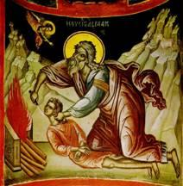
Objectives:
- Children should be able to tell the story of Isaac – his birth, the sacrifice on the mountain, and his marriage. (The focus is on obedience and trusting God)
- Children should identify Isaac as the son of Abraham and Rebekah as his wife.
Lesson Plan:
- Tell the story of Isaac, The Children’s Bible Reader leaves out the story of the sacrifice on the mountain, but does include the story of Rebecca on pages 34-36. Using Genesis 21:1-6, 22:1-18, 24:1-17, tell the children the story of the sacrifice in terminology that is appropriate for the child. Help them to think about the similarity between Abraham sacrificing his son, and God sacrificing His son, Jesus

- True or False:
- Isaac was the son of Abraham (TRUE)
- Sarah was Isaac’s wife (FALSE)
- Abraham was ready to obey God (TRUE)
- Rebekah was Isaac’s mother (FALSE)

- Draw a family tree:
  - Children can use the provided construction paper to make a family tree, either drawing one or using the construction paper to make/cut/glue
  - Begin by drawing a simple family tree for Abraham and Sarah, add Isaac, then Rebekah.
  - The children can then make a family tree of their own family to illustrate Daddy, Mommy, children, and any additional relatives they want.
- There are three color pages included for this week if the children choose to color them in addition to the family tree. The younger children can color the pages INSTEAD of the family tree project if that is better suited to them.

