Abraham 3-5; 6-9 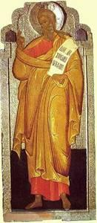
Objectives:
- Children should be able to tell the story of Abraham.
- Children should identify Abraham as the father of the Jewish people, chosen by God.
Lesson Plan:
- Read the story of Abraham from the Children’s Bible Reader, pages 29-33, or God is With Us pages 17-21
- True/False questions:
  - Abraham was married to Sarah (TRUE)
  - A king told Abraham to leave home (FALSE – God did)
  - Abraham traveled on a magic carpet (FALSE – a camel)
  - Abraham’s son was named Isaac (TRUE)
- Discuss moving:
  - Has anyone moved to a new house?
  - What would you pack if you had to carry it all on a camel?
  - Have you ever been camping, pitching a tent each night in a different place? What is it like?
- Have some fun with camels:
  - What do they look like?
  - What are their natures?
  - Get a book from the library to show camels.

- Make an Egg-Carton Camel:
  - Use the painted egg carton section for the body of the camel
  - Bend pipe cleaners through the holed for legs, head, and tail
