ABRAHAM Middle School 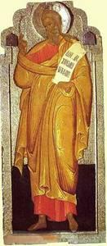

Objectives:
- Students should be able to tell the story of Abraham.
- Students should identify Abraham as the father of the Jewish people, chosen by God.

Lesson Plan:
1. Open with prayer.
- Scripture Reference: Genesis 12:1-8, 17:1-8, 18:1-15. As you read, follow his path on the map. Read also God is With Us pages 17-21.

- Discussion: Abraham is held up in the New Testament as an example of faith.
  - What did God ask Abram to do?
  - What questions would you have had of God before selling everything and loading your camels?
  - How did Abram become Abraham?
  - Why did God give him a new name?
  - Sometimes we take a new name at baptism. Why?

5. Make a Trinity icon: The story of the 3 men visiting Abraham is the source for Rublev’s very well-known icon of the Trinity with the 3 Persons seated at a table.
1. paint a wooden plaque about 5x7 a solid color with acrylic paint.
2. While that’s drying, cut out the icon below.
3. Glue the icon to the plaque, which should be dry now.
4. Spray with clear spray after they dry overnight

