Noah 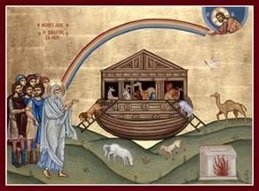

Objectives
- Children should be able to tell the story of Noah and the ark
- Children should identify the Great Flood and its significance
- Children should know God’s meaning for a rainbow.

Lesson Plan: Scripture Reference: Genesis 6:9-8. A bit long but difficult to leave any part out
Questions:
- How do you think Noah felt building a huge boat in his back yard with all the neighbors laughing at him?

- Have people ever laughed at you? How did it feel? How did you respond?

- How did Noah respond?

Optional: Make a rainbow: String beads on the two yellow Pipe Cleaners. When completed, twist the two beaded cleaners together and connect at each end. Glue cotton balls (clouds) over the bent ends and tie a small string in the middle for a hanger.

