Noah 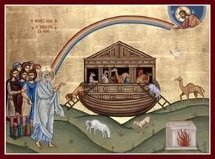

Objectives
- Children should be able to tell the story of Noah and the ark
- Children should identify the Great Flood and its significance
- Children should know God’s meaning for a rainbow.
Lesson Plan:
- Tell the story from the Children’s Bible Reader, pages 24-27 and God is
- Have several small stuffed and/or toy animals, a rock, a pencil, and several other non-animal things. Have the children one by one choose something that Noah would have taken (i.e., an animal) and place it in a basket/box/bag (represents the ark).
- Discuss storms. Thunderstorms, hurricanes, tornadoes – all are scary.
- Ask the children what scares them: the wind? the rain? the thunder? the lightning?
- Imagine how Noah and his family might have felt during the 40 days of storm.
- Discuss rainbows:
  - What did God say to Noah with the rainbow?
  - Have they seen a rainbow?
  - What colors are in a rainbow?
Projects:
- Using the sticker sheet and a piece of blue construction paper, create a scene with Noah’s Ark and the animals. Allow the children to decide which animals to include in their pictures. Ensure they understand that if they place an animal in the picture, they must place 2 of that animal
- Create a pipe-cleaner rainbow. Thread colored beads on each of the two pipe cleaners provided. When they are filled with colored beads, twist the two together loosely and connect at the ends, then shape it like a rainbow

