Noah 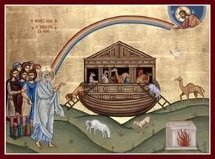

Objectives:
- Children should be able to tell the story of Noah and the ark.
- Children should identify the Great Flood and its significance.
- Children should know God’s meaning for a rainbow.
Lesson Plan:
- Tell the story from the Children’s Bible Reader, pages 24-27.
- Have several small stuffed animals, a rock, a pencil, and several other nonanimal things. Have the children one by one choose something that Noah would have taken (i.e., an animal) and place it in a bag, box or a basket (represents the ARK), Color the page with Noah bringing the lions onto the Ark
- Talk about storms; use the coloring page showing a storm and lightening.
  - Thunderstorms, hurricanes, tornadoes – all are scary.
  - Ask the children what scares them: the wind? the rain? the thunder? the lightning?
- Discuss rainbows:
  - What did God say to Noah with the rainbow?
  - Have they seen a rainbow?
  - What colors are in a rainbow? Color the picture of Noah and the Ark with the Rainbow
Optional Projects:
Make a pipe-cleaner rainbow. Take the 2 pipe cleaners and hold together, then string colored beads onto both of the pipe cleaners and bend in the shape of a rainbow. Bring the rainbow to class to share. If the child does not make the rainbow, they can bring their color pages to share after services on Sunday.
Project 2: There is a piece of blue construction paper in this week’s packet and a sheet of stickers with the Noah’s Ark story. The child can use the stickers to re-create the Noah story on the blue paper.
- Ask the child to name animals that would have been taken on the ark. Locate stickers for the animals they name, and ensure they understand why they need to put two of that animal on their paper.
- They do not need to use all the stickers, this is their picture and the animals can go anywhere the child would like to create their picture
- There may not be a sticker for every animal they name, they can draw any animals they do not find a sticker for if they would like to.

